**Automation Testing Capstone Project**

**Create a Testing Framework for Sporty Shoes Website**

**Name : Mrinalini**

Github : https://github.com/mrinalini2110/ATE_CAPSTONE_FINAL_PROJECT.git

**Problem Statement and Motivation Real-Time Scenario:**

Sporty Shoes has an e-commerce website that has the following existing features in place: I used <https://neemans.com/> for the task.

• Users can view products , I wrote some functionality for that also .

• If users want to purchase something, they can first sign up and then log in

• Users can add multiple items to their cart and do a checkout.

• Users have a dashboard that lets them edit their profile, view past purchases, and view their cart

• Once users do a checkout, the items are cleared from their cart and an order is generated which is stored in their order history The above application is already functional. What is needed now is to add a testing layer that will ensure that everything is passed through QA.

**Task:**

The following tasks outline the testing framework creation:

1. Add additional code to the original project to add a REST API module. This module will have two API endpoints:

• Retrieve the list of all products in the store

• Retrieve the list of all registered users

2. Create Selenium scripts to test all the pages in the web app

3. Do unit testing for all the backend classes and methods

4. Create JMeter scripts to do load testing of the homepage and the product detail page

How to execute :

1. Import the project in eclipse IDE
2. Identify testNG.xml
3. Run testNG.xml
4. Open the jmiter file provide there and run it .

**Task 1 Screenshots :**

**For products :**

**For users :**

**Task 2 & 3 Screenshots :**

**Folder structure :**

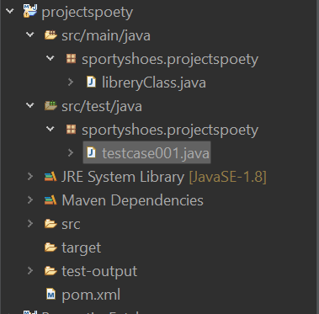

**Moduler code :**

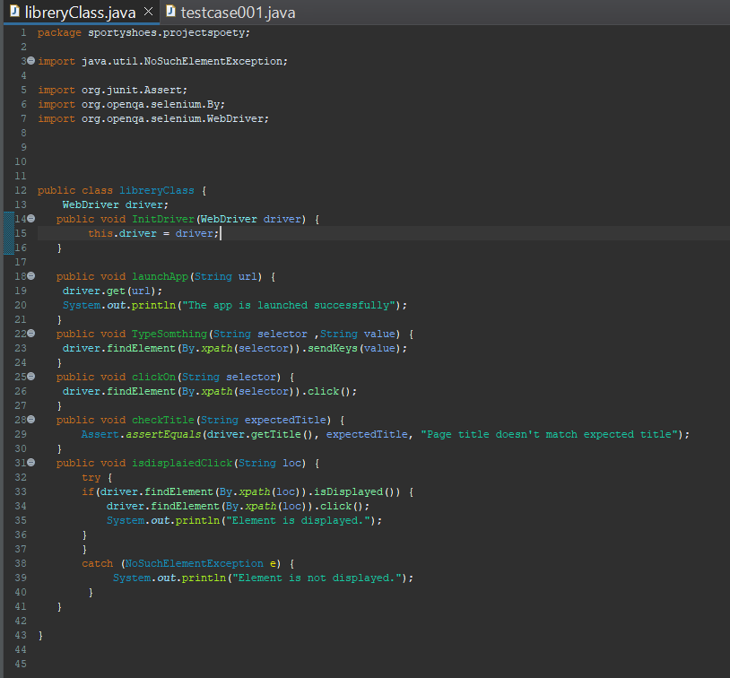

Actually I’m facing some issue with the popup that comes dynamicly to the website that I’m using now . and I can’t complete my task for that reason .

All the rest task is done and I create the login , signup test , product view , add cart test , add multiple products , also I did the checkout code .

**Task 4 Screenshots :**

Result of the load testing .

